Bradley Mont

Com Sci 32

Professor Smallberg

Lecture 2, Discussion 2C

UID: 804-993-030

Programming Assignment 2: Double Trouble

Design Description

I implemented the Map class using a doubly-linked list. The list is not circular and does not contain a dummy node. Instead of a dummy node, it contains a head pointer that points to the first node of the list. The nodes are not sorted any specific way; they are simply in the order of which they were inserted into the list. Each node added goes at the end. Each node contains a KeyType variable and a ValueType variable. Plus, each node has a next pointer that points to the next node and a prev pointer that points to the previous node.

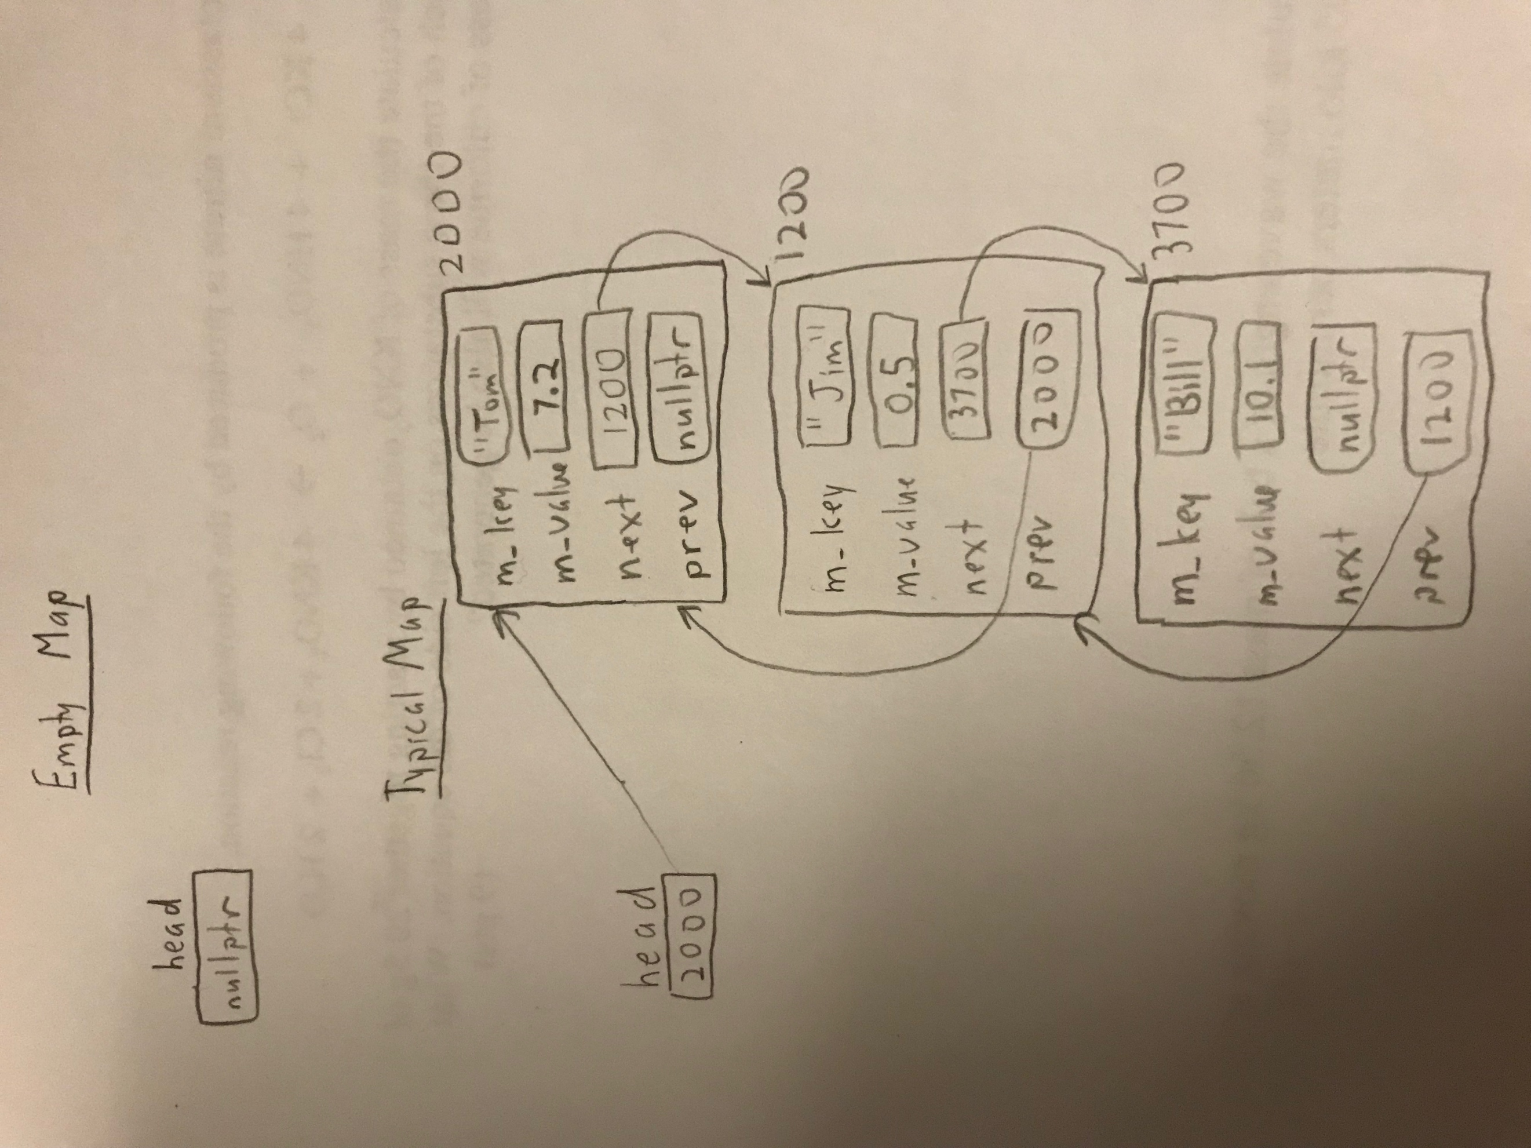

Pseudocode

bool Map::insert(const KeyType& key, const ValueType& value)

{

check if the key is already in the map

if the list is empty

allocate a new node with the given key and value

have head point to the new node

if the list isn’t empty

increment p until it points to the last node

allocate the new node

have p’s next variable point to the new node, and the new node’s prev pointer point to p

increment the size

}

bool Map::erase(const KeyType& key)

{

return false if the list doesn’t contain the key

if we’re erasing the first node

set head to the next node

delete the node with the value given in the parameter

if we’re deleting an interior node or the last node

increment p until it points to the node above the node to be deleted

update the next and prev pointers of the neighboring nodes

delete the node with the value given in the parameter

subtract one from the size

}

void Map::swap(Map& other)

{

check for aliasing

swap head pointers

swap sizes

}

bool combine(const Map& m1, const Map& m2, Map& result)

{

create a temporary result

copy all of m1 into the temporary result

iterate through m2

if the temporary result doesn’t already contain a key

add it to the temporary result

if the temporary result already contains that key

return false and exit the function without actually changing the parameter

if the values don’t match for the corresponding key in m1 and m2

continue iterating if the values do match

copy the temporary result into the actual result

}

void subtract(const Map& m1, const Map& m2, Map& result)

{

create a temporary result

iterate through all of m1

if m2 doesn’t already contain a given key

add that key to the temporary result

copy the temporary result into the actual result

}

Test Cases

//The tests were performed on a map from strings to doubles

// default constructor

Map m;

// For an empty map:

assert(m.size() == 0); // test size

assert(m.empty()); // test empty

assert(!m.erase("Ricky")); // nothing to erase

assert(!m.update("Tom", 17.2)); //nothing to update

assert(!m.contains("Tom")); //doesn't contain anything

string s = "unchanged";

double d = 10;

assert(!m.get("Ricky", d)); //key isn't equal to any key in the map

assert(!m.get(0, s, d)); // i isn't less than size so should return false and leave variables unchanged

assert(s == "unchanged" && d == 10); //both gets should leave the values unchanged

//copy constructor

Map toBeCopied;

toBeCopied.insert("first", 1);

toBeCopied.insert("second", 2);

toBeCopied.insert("third", 3);

toBeCopied.insert("fourth", 4);

Map copy(toBeCopied);

assert(toBeCopied.size() == copy.size());

assert(copy.contains("first"));

assert(copy.contains("fourth"));

//assignment operator

Map assigned;

assigned = toBeCopied;

assert(toBeCopied.size() == assigned.size());

assert(assigned.contains("first"));

assert(assigned.contains("fourth"));

//insert function (for keys not already in the list)

assert(m.insert("A", 10));

assert(m.insert("B", 20));

assert(m.insert("C", 30));

assert(m.insert("D", 40));

assert(m.insert("E", 50));

assert(m.insert("F", 60));

assert(m.size() == 6); // test size

assert(!m.empty()); // test empty

//insert function (for keys matching first item)

assert(!m.insert("A", 10)); //test insert (when already in list/same value)

assert(!m.insert("A", 12)); //test insert (when already in list/different value)

//insert function (for keys matching a middle item)

assert(!m.insert("D", 10)); //test insert (when already in list/same value)

assert(!m.insert("D", 12)); //test insert (when already in list/different value)

//insert function (for keys matching the last item)

assert(!m.insert("F", 10)); //test insert (when already in list/same value)

assert(!m.insert("F", 12)); //test insert (when already in list/different value)

//update function (for first item)

assert(m.update("A", 11)); //test update (when key exists)

assert(m.get("A", d)); //test get when key exists

assert(d == 11); //test that the update function changed the key

//update function (for a middle item)

assert(m.update("C", 31)); //test update (when key exists)

assert(m.get("C", d)); //test get when key exists

assert(d == 31); //test that the update function changed the key

//update function (for the last item)

assert(m.update("F", 61)); //test update (when key exists)

assert(m.get("F", d)); //test get when key exists

assert(d == 61); //test that the update function changed the key

//update function (for a key not equal to any in the map)

assert(!m.update("H", 61)); //testing update when key doesn't exist

//insertOrUpdate function (for first item)

assert(m.insertOrUpdate("A", 12)); //should always return true

assert(m.get("A", d)); //test get when key exists

assert(d == 12); //test that insertOrUpdate changed the key

//insertOrUpdate function (for middle item)

assert(m.insertOrUpdate("C", 32)); //should always return true

assert(m.get("C", d)); //test get when key exists

assert(d == 32); //test that insertOrUpdate changed the key

//insertOrUpdate function (for first item)

assert(m.insertOrUpdate("F", 62)); //should always return true

assert(m.get("F", d)); //test get when key exists

assert(d == 62); //test that insertOrUpdate changed the key

//insertOrUpdate function (for a key not equal to any in the map)

assert(m.insertOrUpdate("G", 70)); //should always true

assert(m.size() == 7); //test updated size

//erase function (for a key not equal to any in the map)

assert(!m.erase("L"));

//erase function (for the first element)

assert(m.erase("A"));

assert(!m.contains("A"));

assert(m.size() == 6);

//erase function (for a middle element)

assert(m.erase("C"));

assert(!m.contains("C"));

assert(m.size() == 5);

//erase function (for the last element)

assert(m.erase("G"));

assert(!m.contains("G"));

assert(m.size() == 4);

//contains function (for a key currently in the map)

assert(m.contains("B"));

assert(m.contains("D"));

//contains function (for a key not currently in the map)

assert(!m.contains("A"));

assert(!m.contains("d"));

//get function with 2 parameters (for a key currently in the map)

string testString = "test";

double testDouble = 9.6;

assert(m.get("E", testDouble));

assert(testDouble == 50);

//get function with 2 parameters (for a key not currently in the map)

assert(!m.get("A", testDouble));

assert(testDouble == 50); //should remain unchanged

//get function with 3 parameters (for an invalid i)

assert(!m.get(-1, testString, testDouble)); // i < 0

assert(!m.get(4, testString, testDouble)); // i = size()

assert(!m.get(5, testString, testDouble)); // i > size()

assert(testString == "test" && testDouble == 50); //should remain unchanged

//get function with 3 parameters (for first item)

assert(m.get(0, testString, testDouble));

assert(testString == "B" && testDouble == 20);

//get function with 3 parameters (for a middle item)

assert(m.get(2, testString, testDouble));

assert(testString == "E" && testDouble == 50);

//get function with 3 parameters (for the last item)

assert(m.get(3, testString, testDouble));

assert(testString == "F" && testDouble == 62);

Map a;

a.insertOrUpdate("a", 1);

a.insertOrUpdate("b", 2);

a.insertOrUpdate("c", 3);

a.insertOrUpdate("d", 4);

a.insertOrUpdate("e", 5);

a.insertOrUpdate("f", 6);

a.insertOrUpdate("g", 7);

a.insertOrUpdate("h", 8);

Map b;

b.insertOrUpdate("w", 23);

b.insertOrUpdate("x", 24);

b.insertOrUpdate("y", 25);

b.insertOrUpdate("z", 26);

//swap function (for the same Map (aliasing))

a.swap(a); //a should remain unchanged

assert(a.size() == 8);

assert(a.contains("a"));

assert(a.contains("d"));

assert(a.contains("h"));

//swap function (for two different maps)

a.swap(b);

//check a to see if it contains what b previously did

assert(a.size() == 4);

assert(a.contains("w"));

assert(a.contains("x"));

assert(a.contains("y"));

assert(a.contains("z"));

//check b to see if it contains what a previously did

assert(b.size() == 8);

assert(b.contains("a"));

assert(b.contains("b"));

assert(b.contains("c"));

assert(b.contains("d"));

assert(b.contains("e"));

assert(b.contains("f"));

assert(b.contains("g"));

//swap function (when one map goes out of scope)

{

Map c;

c.insertOrUpdate("i", 9);

c.insertOrUpdate("j", 10);

c.insertOrUpdate("k", 11);

c.insertOrUpdate("l", 12);

c.insertOrUpdate("m", 13);

c.swap(a);

//check c to see if it contains what a previously did

assert(c.size() == 4);

assert(c.contains("w"));

assert(c.contains("x"));

assert(c.contains("y"));

assert(c.contains("z"));

}

//check a to see if it contains what c previously did

//it should still work even though c is now deleted since it's out of scope

assert(a.size() == 5);

assert(a.contains("i"));

assert(a.contains("j"));

assert(a.contains("k"));

assert(a.contains("l"));

assert(a.contains("m"));

//copy constructor after swapping with something out of scope

Map n(a);

assert(n.size() == 5);

//assignment operator after swapping with something out of scope

Map p;

p = a;

assert(p.size() == 5);

//testing non-member functions

Map one;

one.insert("A", 5);

one.insert("B", 10);

one.insert("C", 15);

one.insert("D", 20);

one.insert("E", 25);

one.insert("F", 30);

Map two;

two.insert("G", 35);

two.insert("H", 40);

two.insert("I", 45);

two.insert("J", 50);

two.insert("K", 55);

Map result;

//combine function (with 2 different maps and an empty result)

assert(combine(one, two, result));

assert(result.size() == one.size() + two.size());

assert(result.contains("A"));

assert(result.contains("F"));

assert(result.contains("G"));

assert(result.contains("K"));

//combine function (with 2 different maps and a non-empty result)

assert(combine(one, two, result));

assert(result.size() == one.size() + two.size());

assert(result.contains("A"));

assert(result.contains("F"));

assert(result.contains("G"));

assert(result.contains("K"));

//combine function with m1 = m2 and an empty result

Map result2;

assert(combine(one, one, result2));

assert(result2.size() == one.size());

assert(result2.contains("A"));

assert(result2.contains("F"));

//combine function with m1 = m2 and a non-empty result

assert(combine(one, one, result2));

assert(result2.size() == one.size());

assert(result2.contains("A"));

assert(result2.contains("F"));

//combine function with m1 = result

Map originalOne(one);

assert(combine(one, two, one)); //one is indirectly modified

assert(one.size() == originalOne.size() + two.size());

assert(one.contains("A"));

assert(one.contains("F"));

assert(one.contains("G"));

assert(one.contains("K"));

//combine function with m2 = result

Map originalTwo(two);

assert(combine(originalOne, two, two));

assert(two.size() == originalOne.size() + originalTwo.size());

//combine function with m1 and m2 having similar keys and values (with empty result)

Map result3;

Map dups;

dups.insert("A", 5);

dups.insert("D", 20);

dups.insert("F", 30);

assert(combine(originalOne, dups, result3));

assert(result3.size() == 6);

assert(result3.contains("A"));

assert(result3.contains("F"));

//combine function with m1 and m2 having similar keys and values (with non-empty result)

assert(combine(originalOne, dups, result3));

assert(result3.size() == 6);

assert(result3.contains("A"));

assert(result3.contains("F"));

//combine function with m1 and m2 having similar keys with conflicting values (with empty result)

Map result4;

assert(dups.update("A", 6));

assert(!combine(originalOne, dups, result4));

assert(result4.empty());

//combine function with m1 and m2 having similar keys with conflicting values (with empty result)

Map result5;

assert(result5.insert("not empty", 2));

assert(!combine(originalOne, dups, result5)); //result5 should remain untouched

assert(result5.contains("not empty"));

assert(result5.size() == 1);

//subtract function with m1 != m2 and an empty result

Map m1 = originalOne;

Map m2 = originalTwo;

Map res;

subtract(m1, m2, res);

assert(res.size() == m1.size());

assert(res.contains("A"));

assert(res.contains("F"));

//subtract function with m1 != m2 and a non-empty result

subtract(m1, m2, res);

assert(res.size() == m1.size());

assert(res.contains("A"));

assert(res.contains("F"));

//subtract function with m1 == m2 and an empty result

Map res2;

subtract(m1, m1, res2);

assert(res2.empty());

//subtract function with m1 == m2 and a non-empty result

subtract(m1, m1, res);

assert(res.empty()); //res becomes empty

//subtract function with m1 and m2 having similarities and an empty result

Map m3;

assert(m3.insert("A", 2));

assert(m3.insert("F", 90));

subtract(m1, m3, res);

assert(!res.contains("A"));

assert(!res.contains("F"));

assert(res.size() == 4);

//subtract function with m1 and m2 having similarities and a non-empty result

subtract(m1, m3, res);

assert(!res.contains("A"));

assert(!res.contains("F"));

assert(res.size() == 4);

//subtract function where m1 = result (aliasing) and no similarities

subtract(m1, m2, m1);

assert(m1.size() == 6);

assert(m1.contains("A"));

assert(m1.contains("F"));

assert(!m1.contains("G"));

//subtract function where m1 = result (aliasing) and similarities

m2.insert("A", 2345);

subtract(m1, m2, m1);

assert(m1.size() == 5);

assert(!m1.contains("A"));

assert(m1.contains("B"));

assert(m1.contains("F"));

assert(!m1.contains("G"));